Useful info

P.E. kits on Fridays. Forest school kits on Tuesdays.

Reading book and journals daily, school library books returned Mondays.

Art and DT

In Design Technology this term we will be looking at mechanisms and moving parts to help us make a moving vehicle

In Art we will be learning about weaving. Next term we will learn to block print during a day workshop.

Music

This term we are learning a friendship song.

Rabbit class | Summer Term

Predator

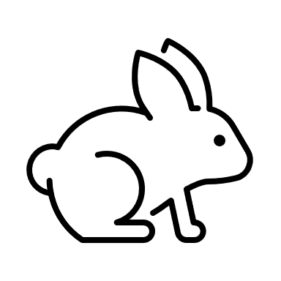

Ways to help your child…

Please continue to read at home, this will help to improve their confidence and fluency in reading and writing.

Your child also has log-in details for Teach your Little Monster to Read, Reading Just for Fun and Teach your Monster Number Skills as well as TT Rockstars. All these can be accessed via their website.

RE / PHSE

In PHSE we will be learning about personal safety, how to keep ourselves safe and how to share how we are feeling.

In RE, we will be exploring Islam this half term and Christianity and the Easter story next half term.

English

In English, we will reading the Day the Crayon’s Quit and learning how to persuade people with a poster. In our next unit we will be looking at poems on a theme.

We have daily phonics lessons along with class reading; focussing on fluency, retrieval and beginning to look at inference.

History and Geography

Next term we will be looking at the physical and human characteristics of the United Kingdom, including a detailed exploration of the characteristics and features of our capital city, London.

Science

Our science focus for the first half term will be looking at food chains, the diet of different animals and how their bodies have adapted for this.

Next half term, we will be looking at the environment, recycling and energy.

Maths

This term we are completing our work on measurement, so why not get your child to help out measuring ingredients in the kitchen. We will then focus on identifying the properties of different 2D and 3D shapes and look at finding fractions of numbers and shapes.

We will also be continuing our practising of times tables. By the end of year 2 children should know x2, x5, x10